**HUMAN BIOLOGY – YEAR 12**

**TASK 6 – REFLEX AND REACTIONS INVESTIGATION**

**MARKING KEY**

**Sense Receptors in the Skin – Investigation of heat and cold receptors**

1. Describe how the subject felt when the right finger was immersed in: [1 mark]  
   1. Cold water: cold
   2. Room Temperature: warm
2. Describe how the subject felt when the left finger was immersed in: [1 mark]  
   1. Hot water: warm
   2. Room Temperature: cold
3. What is the name given to temperature receptors in the skin? [1 mark]

* Thermoreceptor

1. Explain:
   1. The reason for this discrepancy by the receptors in the fingers in feeling the correct temperature. [2 marks]

* When temperature receptors get used to a certain amount of heat or cold, they adapt (1)
* And become less sensitive to the environment they are in (1)
  1. Why this would be useful in a person’s everyday life. [2 marks]

*Any 2 of the following: or any appropriate response.*

* Allows us to tune out background sensations (1)
* If didn’t then we would have constant input of too many competing sensations (1)
* Body would be overloaded with sensations (1)

**Reactions – Measuring the speed of a nerve impulse and the reaction time**

**RESULTS** [1 mark]

* Correctly determines reaction times (1)

**ANALYSIS**

1. Did the reaction time of the subject decrease or increase over the 4 trials? [1 mark]

* Should decrease / answer based on average change in data (1)

1. What do you notice about difference between the dominant hand and non-dominant hand reaction time? Explain. [3 marks]

* Dominant hand faster (1)
* Neural pathways more set (1)
* As used more regularly (1)

*Or any appropriate response*

1. How did the reaction speeds compare for the three experiments where the subject’s eyes were closed? [3 marks]

* When head was tapped the reaction time was fastest (1)
* When the hand was tapped was next faster (1)
* When the foot was tapped was slowest (1)

1. Is the reaction for catching a ruler voluntary or involuntary? Explain. [3 marks]

* Voluntary (1)
* Under conscious control (1)

1. How does repetition of a task (practice) affect reaction time? What happens to neural pathways in the brain? [3 marks]

*Any 3 of the following:*

* Allows a person to practice / train (1)
* Which improves their ability to complete a task (1)
* Neural pathways become more set /developed (1)
* Action become better/consistent (1)

*Any appropriate response*

**Reflexes – Investigating the blink reflex**

**ANALYSIS**

1. What did the subject do when the cotton ball was thrown at their eyes? [1 mark]

* Blinked when the cotton ball was thrown at eyes (1)

1. Why do you think you made the observations you did? Included in your response should be the purpose of reflexes to the human body. [3 marks]

* To stop the cotton ball from entering the eye (1)
* This is protective measure for the body (1)

1. 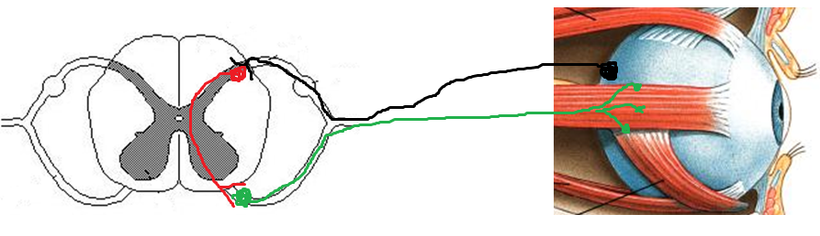Using the images below, draw and label the possible reflex arc that a nerve impulse would have taken when the cotton ball was thrown at the subject’s eye. [4 marks]

Sensory neuron

* All correct = 4
* Minor error = 3
* 50% correct = 2

Interneuron

* At 2 things correct = 1

Motor neuron

1. Why is reflex testing an important diagnostic tool in physical examinations of patients by physicians (doctor)? [1 mark]

* Distorted, exaggerated or absent reflex responses may indicate degeneration of pathology of portions of the nervous system, often before other signs are apparent. If the spinal cord is damaged, then reflex tests can help determine the area of the injury.

**CONCLUSION**

1. How does the brain:
   1. Receive messages from sense organs (eyes, ears, skin, etc)? [1 mark]

* Sensory neurons (1)  
    
  Send messages back to muscles? [1 mark]
* Motor neurons (1)

1. Imagine you are driving at night. Lights from the oncoming traffic ‘hit’ your eyes. Why are you not ‘blinded’ by the intense lights from the oncoming traffic? [3 marks]

* Receptors detect light change (1)
* Reflex makes iris change size / Reflex protects eye by (1)
* Decrease in light entering eye (1)

1. Alcohol is a depressant, meaning it ‘slows down’ the nerve cells/neurons in the Central Nervous System. Explain why it is not recommended for drivers of vehicles to consume alcohol or high amounts of alcohol before getting behind the wheel? [5 marks]

*Any 5 of the following:*

* Nerve impulses are meant to relay messages quickly (1)
* How messages are passed through the body (1)
* Nerve impulse slows down (1)
* If neurons slow down, connections in brain slows (1)
* Stimulus sent to brain slower (1)
* Messages to muscles slower (1)
* Reactions to stimuli are slower (2)
* Poor decisions made (1)
* Accidents due to slow reactions (1)